
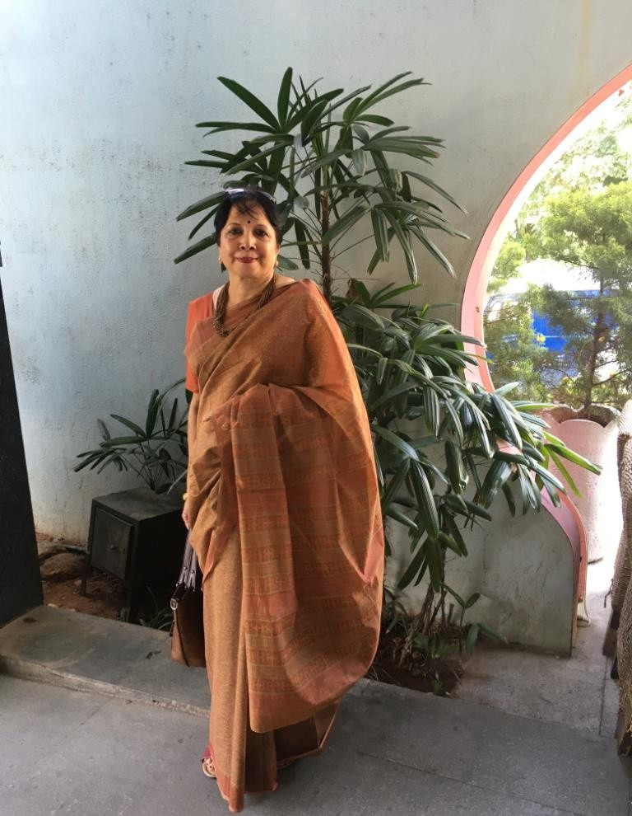

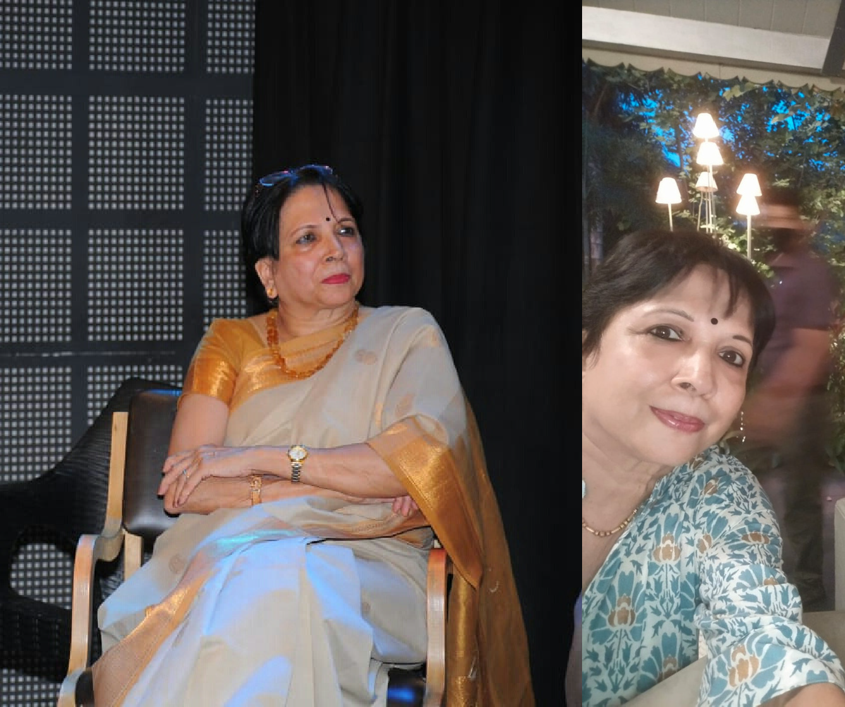
ABOUTME

DR. REMA RAMACHANDRAN

I am Dr. Rema Ramchandran. Ex-Banker with ANZ Grindlays and Standard Chartered. Heading the NRI Services.

Currently Director with IWFCI India, SIGBI Trading Ltd. London, Knowble Minds. Am also a Consultant with India Assetz.

I have done a modelling assignment in the past for Bulls Eye Media for their all India Campaign.

Also received a Prize from the makers of DOVE soap for flawless skin.

Am looking for suitable modelling assignments. Have attached a few pics as well as YouTube videos.

Dr. Rema Ramchandran
+ 91 98450 9582
ramchandran.rema@gmail.com

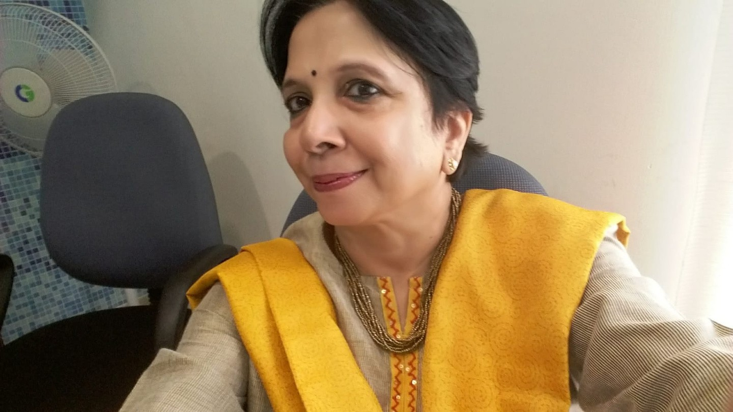
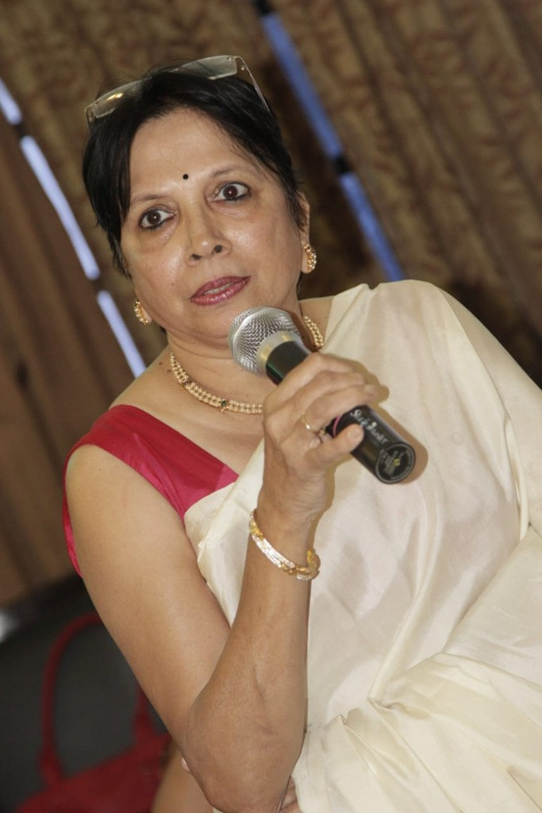
ATTRIBUTES

SKIN
01
Fair - Flawless Skin

HAIR
Black, Short Pixie Cut
02

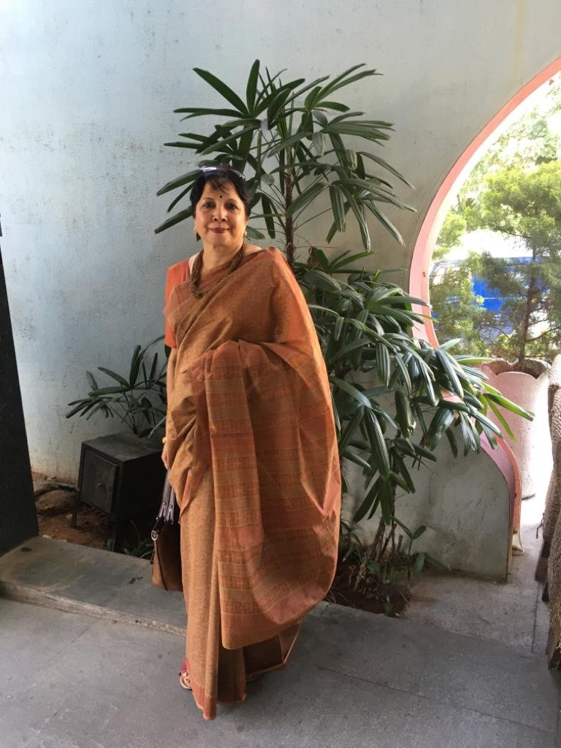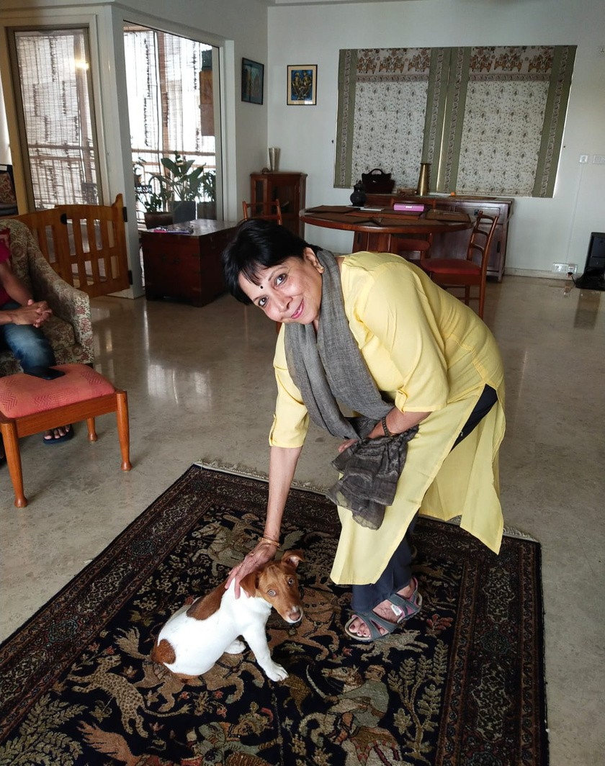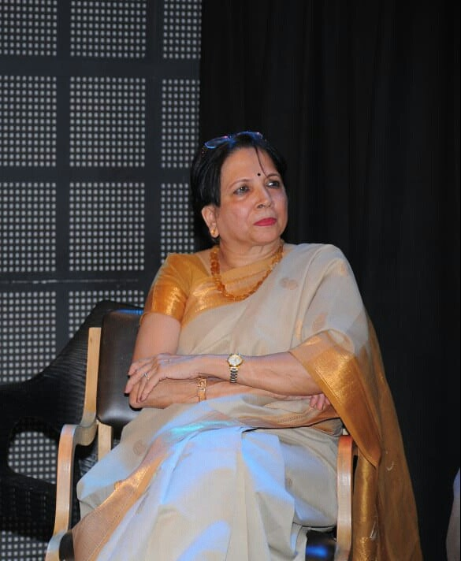

HEIGHT
03
5 FEET, 4 INCHES

WEIGHT
60 KILOS
04

BUILD
SLIM
05

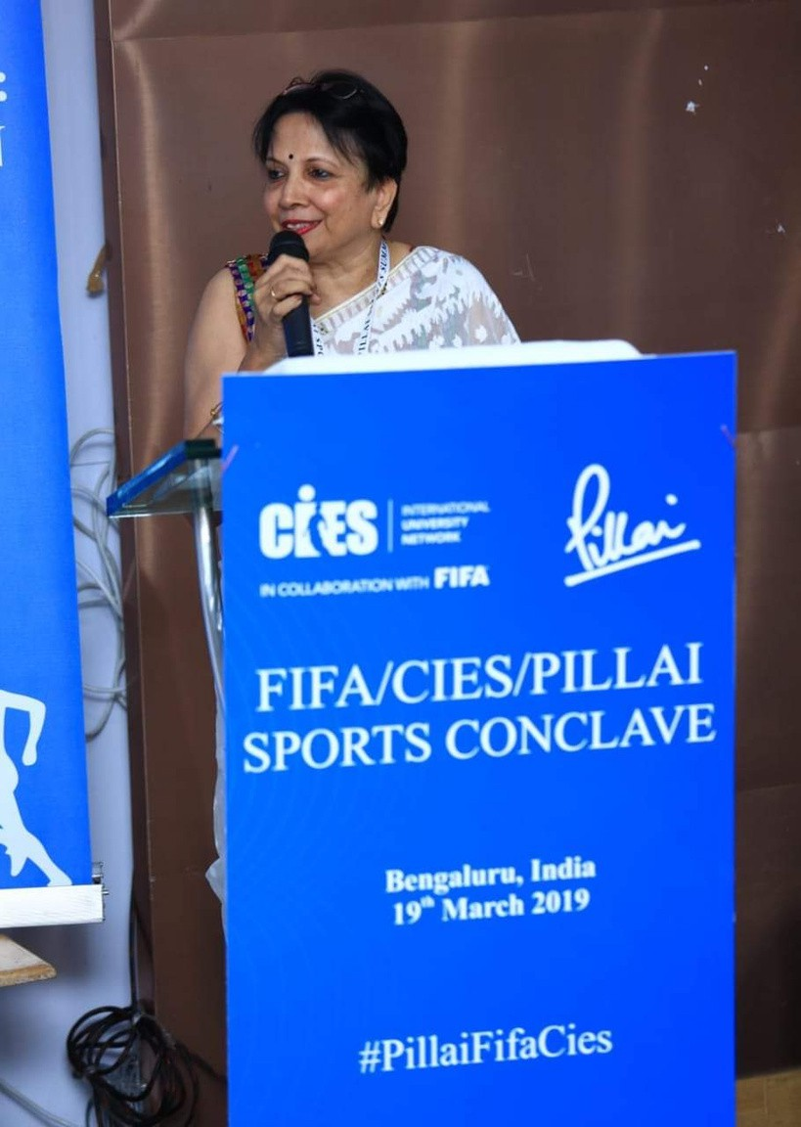

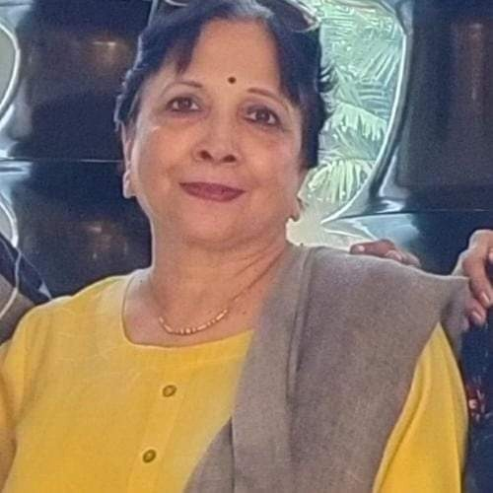
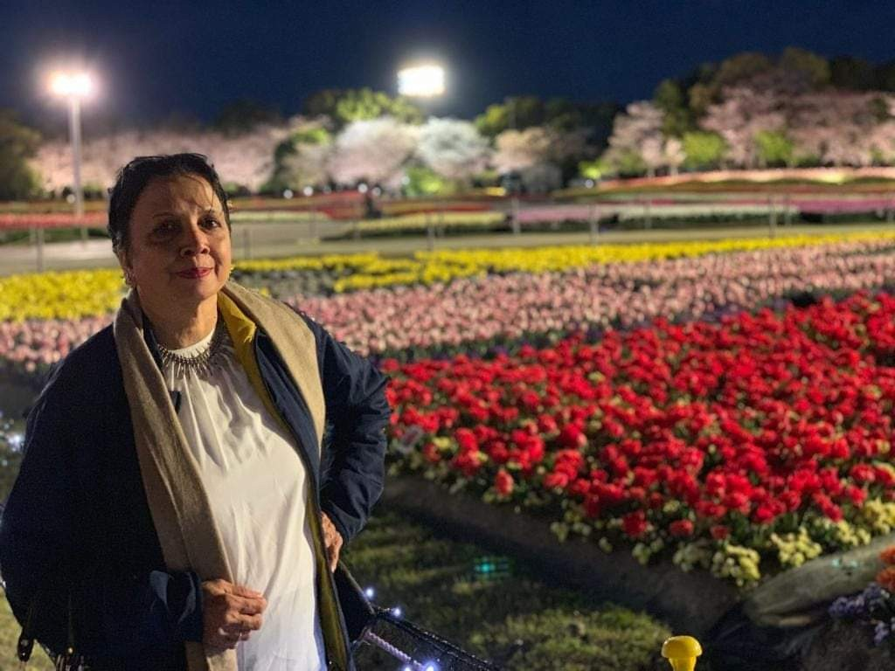


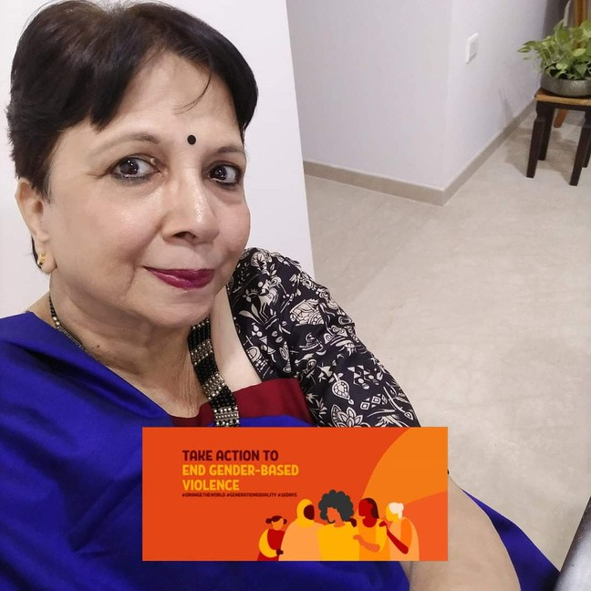
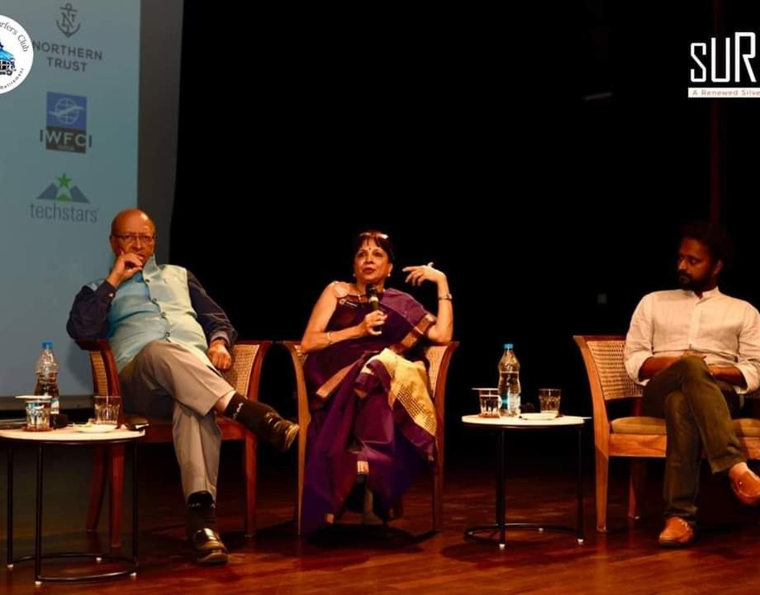




VIDEOS

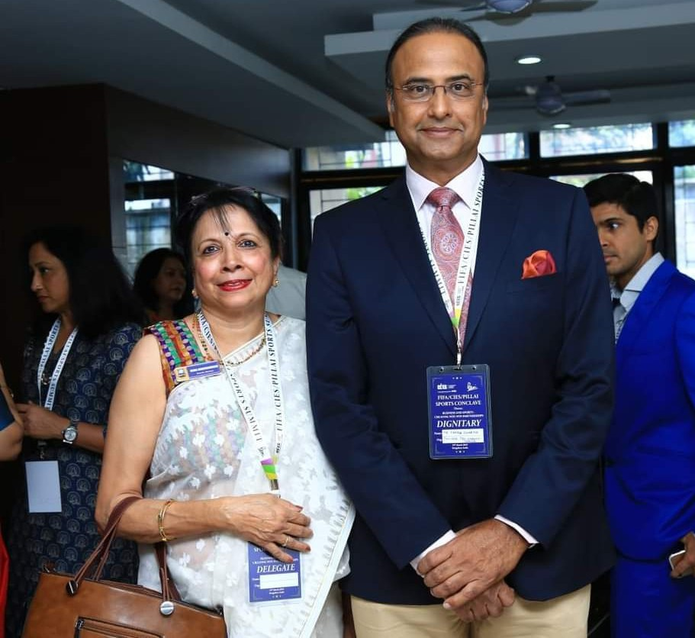
GETIN TOUCH
EMAIL
RAMCHANDRAN.REMA@GMAIL.COM

PHONE
+91 98450 91582

LINKEDIN HTTPS://WWW.LINKEDIN.COM/IN/DR-REMA-RAMCHANDRAN-6830951A

