RACHANA
COMMERCIAL · PRINT · CATALOG · PETITE MODELING · BRAND ENDORSEMENTS

PHYSICAL STATISTICS  LANGUAGES  English, Kannada, Hindi  CONTACT  Email: [krrachana2000@gmail.com]  Phone: [9380212643]  Instagram: @[rachana.ramesh.16] | PROFESSIONAL BIO  Bengaluru-based commercial and print model with a versatile screen presence and expressive camera adaptability. A defined jawline and strong bone structure translate well across close-up beauty work, profile shots, and print. Blends precision, discipline, and energy across high-fashion, ethnic wear, contemporary lifestyle, and e-commerce campaigns. Experienced in delivering dynamic poses, natural expressions, and working efficiently with creative directors and photographers.  MODELING FOCUS & SPECIALIZATIONS  - E-Commerce & Catalog — Ethnic wear (sarees, lehengas), western casuals, and modern fusion wear.  - Commercial & Print — Skincare, beauty campaigns, lifestyle brands, and digital advertisements.  - Petite Fashion — Proportional styling for petite apparel brands and lookbooks.  - Facial Expressiveness — High-definition close-up portraits, beauty shots, and expressive commercial acting.  KEY STRENGTHS  - Presence — Strong posture, spatial awareness, and fluid movement in front of the lens.  - Facial Structure — Defined, photogenic jawline that holds up well across close-up, profile, and beauty shots.  - Versatility — Quick adaptability across aesthetics, from traditional Indian to sleek minimalist modern.  - Professionalism — Punctual and adaptable to long studio shoots or outdoor locations.
  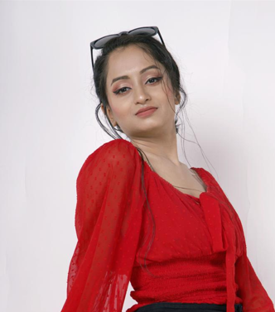
  Height | 5'0" (152 cm)
  Weight | 40 kg
  Age / Screen | 25
  Hair Color | [Black]
  Eye Color | [Black]
  Bust | [32"]
  Waist | [24"]
  Hips | [34"]
  Shoe Size | [UK 5]
PORTFOLIO HIGHLIGHTS

